


Scope and Storyboard for Costs Assessment

AMR Manchester

By SVR

Table of Contents

1 Document Revision History 2
1.1. Document Location 2
1.2. Revision History 2
1.3. Approvals 2
1.4. Distribution 2
2 Summary of Scope 3
3 Screen design 4
4 Workflow 16
5 Navigation 17
6 SQL Tables 18
7 Stored Procedures 20
8 Tasks & Reminders 21
9 Document Templates 22

Document Revision History

Document Location
Full File Path
2011-09-12 FL042 Scope and Storyboard for Costs Assessment V0.5.doc

Revision History
Version Number | Revision Date | Summary of Changes | Changes marked | Author
0.1 | 24/10/2011 | First issue | N/A | SVR
0.2
0.3 | 24/10/2011 | LMW Comments | Tracked | LMW
0.4 | 25/10/2011 | SVR Amendments | Tracked | SVR
0.5 | 17/11/2011 | SVR Amednment | No | SVR

Approvals
Name | Signature | Title | Date of Issue | Version

Distribution
Name | Title | Date of Issue | Version

Summary of Scope

The purpose of this scope is to outline the provisions that the FloCase system will need to make to allow users to handle the process of the Detailed Assessment of Costs, whether on post-litigated files or costs only cases.

It is envisioned that whilst the process itself may be of a complex nature the system should provide a simplified generic solution that merely tracks dates and has a certain amount of supervision inbuilt to assist the Team Leaders in ensuring key tasks involved in these process are dealt with in a timely manner.

  - Assessment

This Scope and Storyboard document refers only to the processes around the Detailed Assessment of Costs Cases, i.e. post litigation matters and matters where the process of negotiation has resulted in the need for a formal review of costs in the matter. As a result, most of the activity in this scope is intended to be launched as ad-hoc actions from the Case Actions Screen. It is assumed that the Costs Draftsperson and Team Administrator in the Matter are sufficiently aware of the business requirements to be able to distinguish which tasks to select when processing these matters.

Most of the activity around the Detailed Assessment of Costs is focussed on the timetable for submissions and responses. A new Tab for Costs Dates, which will also allow Costs team administrators to record other key dates for Negotiation and Settlement of costs is required.

The primary starting point for Costs assessment is the Date of Authority to Assess (see Fig 1 below). This date represents the trigger activity from which point the issue of costs resolution is derived. Because of the nature of Costs, the Authority to Assess may be taken from a wide range of dates, including: date of Settlement of Claimant Damages, the Trial Date, a Judgement, Direction, Order, Award or other Determination. It can also be as a result of Discontinuance, acceptance of a Part 36 Offer, etc.

As there are so many possible points for the Date of Authority to Assess, it is expected that the Date of authority to assess will be entered by the Costs Team administrator once the case is assigned to Costs and not automatically calculated.

Much of the system requirements are focussed around the use of reminders to the Fee Earner in Costs to carry out time limited tasks according to the schedule and timetables set out in the Civil Procedure Rules and by the appropriate courts, and officers of the court. As many of these tasks are ad-hoc in nature, and the preparation of documents in relation to the task reminders is also largely ad-hoc, this scope requires limited workflow and form development.

Screen design

  - Costs Dates Tab

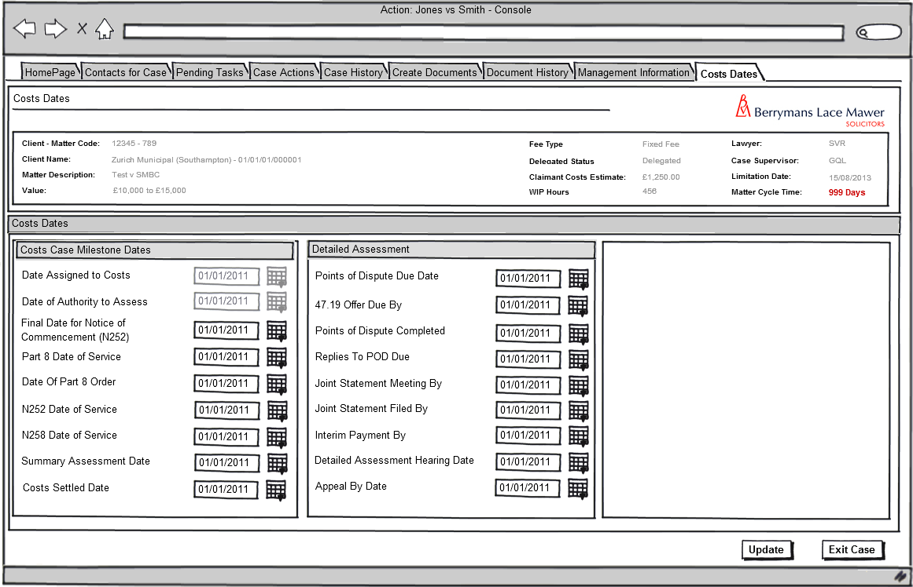
A New Tab is required for Costs Dates to be visible once the Assign Case to Costs Task set out in FLO41 Costs Negotiations is successfully completed and the case has been assigned to costs:

Fig 1: Costs Dates

    - Form Behaviour on Load

This Tab should only be visible if the Date Assigned to Costs field has been completed and there is a Bit value in the field dbo.Case_CostsAssgn = 1 and should load with fields pre-populated with data previously entered using a new Stored Procedure: LTMM_CostsDirections_Fetch
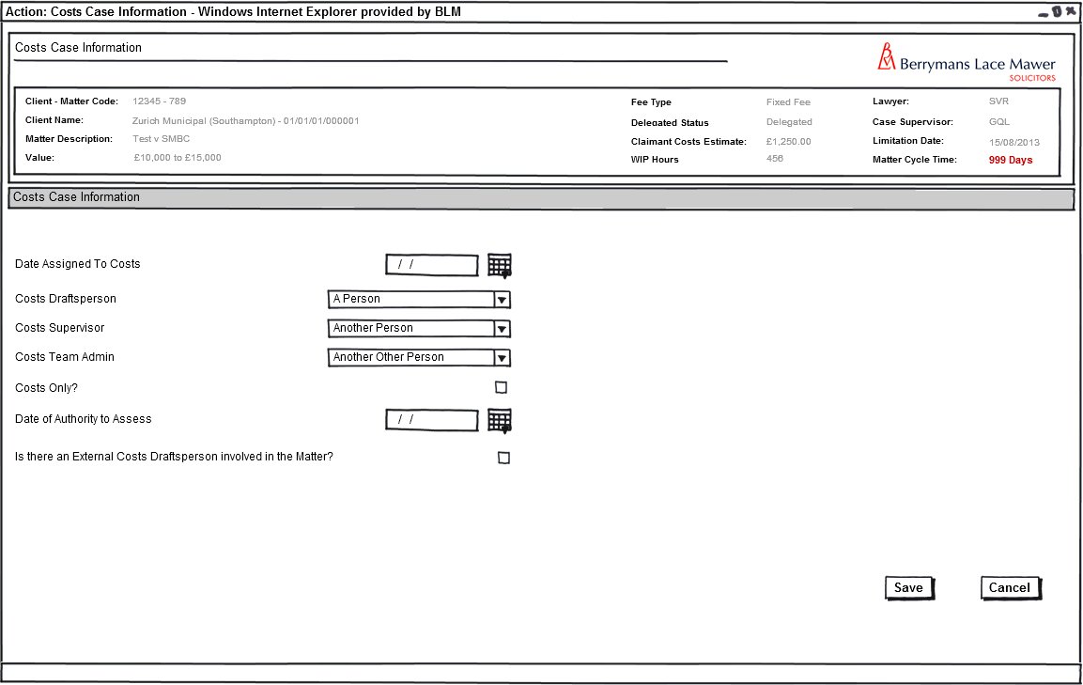
Fig 2: Costs Case Information Form (Negotiations FLO41)

    - Form Items:

Date Assigned to Costs – Label as stated with associated read only date field, populated from field CaseKeyDates_KeyDatesCode @pKeyDatesCode = ‘CostsAssignDate’

Date of Authority to Assess – Label as stated with associated read only date field, populated from field CaseKeyDates_KeyDatesCode @pKeyDatesCode = ‘CostsAuthAss’

Final Date for Notice of Commencement (N252) – Label as stated with associated date picker, value to be saved to CaseKeyDates table with @pKeyDatesCode = ‘CostsN252By’. Default value to be calculated as 3 Months from Date of Authority to Assess, (CaseKeyDates with @pKeyDatesCode = ‘CostsAuthAss’), this field should, however be editable by the user.

Final Date for Request for Hearing (N258) – Label as stated with associated date picker, value to be saved to CaseKeyDates table with @pKeyDatesCode = ‘CostsN258By’. Default value to be calculated as 6 Months from Date of Authority to Assess, (CaseKeyDates with @pKeyDatesCode = ‘CostsAuthAss’), this field should, however be editable by the user.

Part 8 Date of Service – Label as stated with associated read only date field, populated from field ‘PartEight_SvdDate’

Date of Part 8 Order – Label as stated with associated date picker, value to be saved to CaseKeyDates table with @pKeyDatesCode = ‘Prt8OrderDte’

N252 Date of Service – Label as stated with associated date picker, value to be saved to CaseKeyDates table with @pKeyDatesCode = ‘N252DteSvd’

N258 Date of Service – Label as stated with associated date picker, value to be saved to CaseKeyDates table with @pKeyDatesCode = ‘N258DteSvd’

Summary Assessment Date – Label as stated with associated date picker, value to be saved to CaseKeyDates table with @pKeyDatesCode = ‘SumAsstDte’

Points of Dispute Due Date – Label as stated with associated date picker, value to be saved to CaseKeyDates table with @pKeyDatesCode = ‘PODDueDate’

47.19 Offer Due By – Label as stated with associated read only date field, pre-populated from field CaseKeyDates table with @pKeyDatesCode = ‘PODDueDate’ Minus 7 Days. Value to be saved to CaseKeyDates_KeyDatesCode @pKeyDatesCode = ‘4719Offer’

Points of Dispute Completed – Label as stated with associated date picker, value to be saved to CaseKeyDates table with @pKeyDatesCode = ‘PODCompDate’

Replies to POD By – Label as stated with associated date picker, value to be saved to CaseKeyDates table with @pKeyDatesCode = ‘RepliesDueBy’

Joint Statement Meeting By – Label as stated with associated date picker, value to be saved to CaseKeyDates table with @pKeyDatesCode = ‘JSMtgBy’

Joint Statement Filed By – Label as stated with associated date picker, value to be saved to CaseKeyDates table with @pKeyDatesCode = ‘JSFileBy’

Interim Payment By – Label as stated with associated date picker, value to be saved to CaseKeyDates table with @pKeyDatesCode = ‘IntPytBy’

Detailed Assessment Hearing Date – Label as stated with associated date picker, value to be saved to CaseKeyDates table with @pKeyDatesCode = ‘DAHDate’

Appeal By Date – Label as stated with associated date picker, value to be saved to CaseKeyDates table with @pKeyDatesCode = ‘DAHAppealDate’

Costs Settled Date – Label as stated with associated date picker, value to be saved to CaseKeyDates table with @pKeyDatesCode = ‘CostsSttldDate’

    - Form Behaviour on Save

Values to be saved to relevant fields using stored procedure dbo.LTMM_CostsDirections_Save

If there is a value in dbo.CaseKeyDates @pKeyDatesCode = ‘N252DteSvd’ Cancel outstanding task “N252 (Notice of Commencement) receipt required by <date>” if it exists with History Line “No Longer required”.

Schedule Reminder Tasks as Follows (Section 4 below)

Schedule Make 47.19 Offer by <Date> task for Costs Draftsperson in the Matter where <date> = value in dbo.CaseKeyDates @pKeyDatesCode = ‘4719Offer’ is created or amended.

Schedule Prepare Points of Dispute by <Date> task immediately for Costs Draftsperson in the Matter when value entered in dbo.CaseKeyDates where @pKeyDatesCode = ‘PoDDueDate’ is created or amended.

Uncompleted Tasks to be escalated to Team Leader 3 Days prior to Due date or amended due date.

Write history line to dbo.AppTask as follows: “Points of Dispute Due Date <date> Created/Amended”

Schedule Replies to Points of Dispute Due <Date> task for <date> for Costs Team Admin in the Matter when value entered in dbo.CaseKeyDates where @pKeyDatesCode = ‘RepliesDueBy’ is created or amended.

Write history line to dbo.AppTask as follows: “Replies to Points of Dispute due by date <Date> Created/Amended”

Schedule Joint Statement Meeting to be Held by <date> immediately for Costs Draftsperson in the Matter when value entered in dbo.CaseKeyDates where @pKeyDatesCode = ‘JSMtgBy’ is created or amended.

Write history line to dbo.AppTask as follows: “Joint statement meeting to be held by date <Date> Created/Amended”

Schedule Joint Statement to be Filed By <Date> immediately for Costs Draftsperson in the Matter when value entered in dbo.CaseKeyDates where @pKeyDatesCode = ‘JSFileBy’ is created or amended.

Uncompleted Task to be escalated to Team Leader 3 Days prior to Due date or amended due date.

Write history line to dbo.AppTask as follows: “Joint Statement to be Filed by date <Date> Created/Amended”

Schedule Interim Payment By <Date> immediately for Costs Draftsperson in the Matter when value entered in dbo.CaseKeyDates where @pKeyDatesCode = ‘IntPytBy’ is created or amended.

Write history line to dbo.AppTask as follows: “Interim Payment Due by date <Date> Created/Amended”

Schedule Prepare Detailed Assessment Hearing by <Date> task immediately for Costs Draftsperson in the Matter when value entered in CaseKeyDates where @pKeyDatesCode = ‘DAHDate’ is created or amended.

Uncompleted Task to be escalated to Team Leader 3 Days prior to Due date or amended due date.

Write history line to dbo.AppTask as follows: “Detailed Assessment Hearing date <Date> Created/Amended”

Cancel outstanding task “N258 (Request for Hearing) receipt required by <date>” if it exists with History Line “No Longer required”.

Schedule Review Detailed Assessment Hearing Preparations task for 21 days prior to ‘DAHDate’ for Costs Supervisor in the matter

Schedule Appeal Due By <Date> immediately for Costs Draftsperson in the Matter when value entered in dbo.CaseKeyDates where @pKeyDatesCode = ‘DAHAppealDate’ is created or amended.

Costs Reminder Tasks

The following Reminder tasks are to be associated with the relevant Key dates and Directions listed above. When each of the relevant Key Dates is saved or amended, the reminder task should be generated or updated.

All reminder tasks may be re-assigned by the user.

Any reminder task which is loaded, then the user clicks “cancel” should remain outstanding.

  - Prepare Points of Dispute by <Date>

    - Task Behaviour on Complete

Set task Prepare Points of Dispute by <date> as complete

Schedule Reminder Task for Costs Team Admin to “Set Replies Due By Date”

Produce Points of Dispute form for Costs Draftsperson in the Matter to edit.

Write history line to dbo.AppTask as follows: “Points of Dispute Prepared By <user> on <Today’s Date>”

If task remains outstanding 3 Days prior to date stored in CaseKeyDates with @pKeyDateCode = ‘PoDDueDate’, escalate to team leader.

  - Make 47.19 Offer By <Date>

    - Task Behaviour on Complete

Set Task Make 47.19 Offer By <Date> as complete

Load Offers Tab for Costs Draftsperson

  - Replies to Points of Dispute Due <Date>

    - Task Behaviour on Complete

Set Task Replies to Points of Dispute Due <Date> as complete

Write history line to dbo.AppTask as follows: “Replies to Points of Dispute received on <Today’s Date>”

  - Joint Statement Meeting to be Held By <Date>

    - Task Behaviour on Complete

Set Task Joint Statement Meeting to be Held By <Date> as complete

Write history line to dbo.AppTask as follows: “Joint Statement Meeting Held on <Today’s Date>”

  - Joint Statement Due By

    - Task Behaviour on Complete

Set Task Joint Statement to be Filed By <Date> as complete

Write history line to dbo.AppTask as follows: “Joint Statement Prepared by <user> on <Today’s Date>”

If task remains outstanding 3 Days prior to date stored in CaseKeyDates with @pKeyDateCode = ‘JSFileBy’, escalate to team leader.

  - Interim Payment By

    - Task Behaviour on Complete

Set Task Interim Payment By <Date> as complete

Write history line to dbo.AppTask as follows: “Interim Payment Prepared by <user> on <Today’s Date>”

  - Prepare Detailed Assessment Hearing by <DAHDate – 21Days>

    - Task Behaviour on Complete

Set Task Prepare for Hearing on <DAHDate> as complete

Load Detailed Assessment Hearing Form (below) for Costs Draftsperson to complete

If task remains outstanding 3 Days prior to date stored in CaseKeyDates with @pKeyDateCode = ‘DAHDate’, escalate to team leader.

  - Review Detailed Assessment Hearing Preparations

    - Task Behaviour on Complete

Set Task Review Detailed Assessment Hearing Preparations as complete

Write history line to dbo.AppTask as follows: “Detailed Assessment Preparations reviewed by <user> on <Today’s Date>”

  - Appeal Due By <Date>

    - Task Behaviour on Complete

Set Task Appeal Due By <Date> as complete

  - Detailed Assessment Hearing
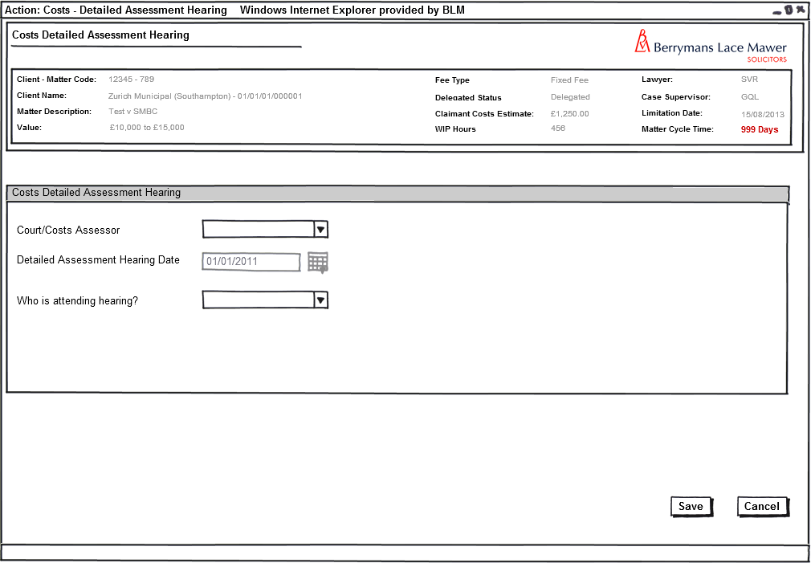
Fig 2: Assigned to Costs and Date Assigned to Costs on Case Details Screen

    - Form Availability

This form should only be available from selection of the task “Prepare for Hearing on <DAHDate>” from the Case Actions Screen

    - Form Behaviour on Load

The form should load with the Detailed Assessment Hearing Date pre-populated by new stored procedure LTMM_DetailedAssessment_Fetch.

    - Form Items

Court/Costs Assessor – label as stated with mandatory combo box having all Courts and Costs Assessors associated with the matter (Populated using new stored procedure: LTMM_DetailedAssessment_Fetch with @LookupTypeCode = “CostCourt”, @BlankRow = 1

Where there is only one Court/one Costs Assessor attached to the matter, this should be the default value, otherwise the field should default to blank.

ContactID Value to be saved to field in new table: dbo.DetailedAssessment_CostCourtID

Detailed Assessment Hearing Date – label as stated with read only date field pre-populated using new stored procedure LTMM_ LTMM_DetailedAssessment_Fetch from field in table CaseKeyDates where @pKeyDatesCode = ‘DAHDate’

Who is Attending Hearing? – label as stated with mandatory combo box having the following options (Populated using LTMM_DetailedAssessment_Fetch with @LookupTypeCode = 'DAHAttend', @BlankRow = 1):
  - Lawyer
  - Counsel
  - Costs Draftsperson
  - External Costs Draftsperson

Default to blank.

Value to be saved to table dbo.DetailedAssessment_DAHAttend

    - Form Behaviour on Save

Schedule Record Detailed Assessment Hearing Outcome for Costs Draftsperson in the Matter for date of Hearing using stored Procedure dbo.AppTask_CreatePending

Record history line as follows: “Preparation for Costs Detailed Assessment Hearing Complete on <today>”

Save Values entered in the form using new stored procedure LTMM_DetailedAssessment_Save

    - Form Behaviour on Cancel

Task “Prepare for Hearing on <DAHDate>” remains Outstanding

Return to Pending Tasks page

  - Review Detailed Assessment Hearing Preparations (Task without Form)

    - Task Behaviour on Complete

Set Task Review Detailed Assessment Hearing Preparations as complete

Write history line as follows: “Detailed Assessment Hearing Preparations Reviewed by <user> on <today>

  - Record Detailed Assessment Hearing Outcome
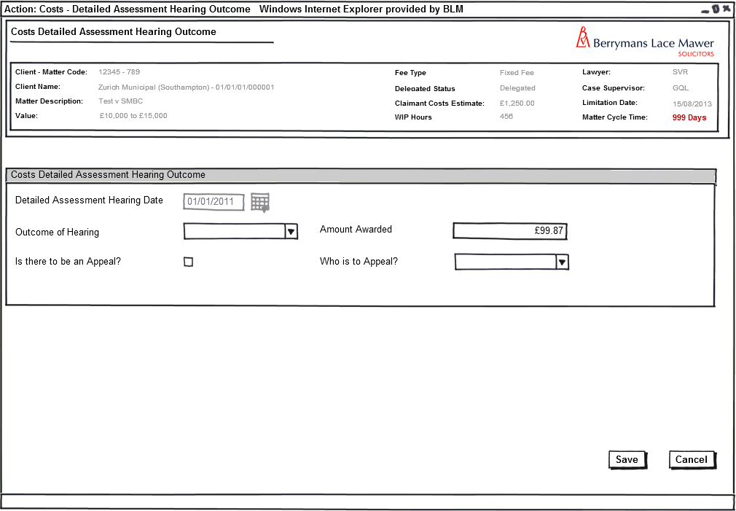
Fig 3: Record Detailed Assessment Hearing Outcome (general)

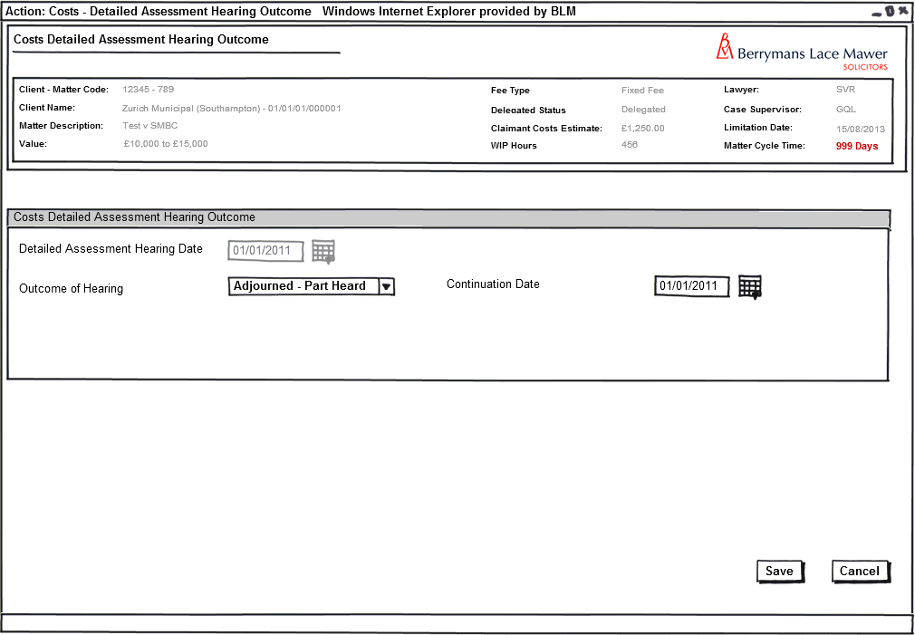
Fig 4 Record Detailed Assessment Hearing Outcome (Adjourned Part Heard)

    - Form Availability

This form should only be available when scheduled from Detailed Assessment hearing as outlined in section 4.8 above.

    - Form Behaviour on Load

The form should load with the Date of Detailed Assessment Hearing pre-populated by new stored procedure LTMM_DetailedAssessment_Fetch.

    - Form Items

Detailed Assessment Hearing Date – label as stated with read only date field pre-populated using new stored procedure LTMM_Detailedassessment_Fetch from field in table CaseKeyDates where @pKeyDatesCode = ‘DAHDate’

Outcome of Hearing – label as stated with mandatory combo box having the following options (Populated using LTMM_LookupCodes_Fetch with @LookupTypeCode = 'DAHResult', @BlankRow = 1):
  - Adjourned
  - Adjourned Part Heard
  - Costs Awarded to Paying Party
  - Costs Awarded to Receiving Party
  - No Costs Order Made
  - Joint Costs Award
  - Vacated by Consent

Default to blank.

Value to be saved to table dbo.DetailedAssessment_DAHResult

Continuation Date – Label as stated with associated date picker. Field only visible if value selected in Outcome of Hearing = “Adjourned Part Heard” (see Fig 4).

Mandatory if visible.

Value to be saved to dbo.CaseKeyDates table with @pKeyDatesCode = ‘DAHDate’

Reschedule Date – Label as stated with associated date picker. Field only visible if value selected in Outcome of Hearing = “Adjourned” (see Fig 4).

Mandatory if visible.

Value to be saved to dbo.CaseKeyDates table with @pKeyDatesCode = ‘DAHDate’

Note that this is the same as the Continuation date field with an altered field label to reflect the fact that the hearing is to be rescheduled rather than continued as a result of an adjournment.

Amount Awarded – label as stated with text box formatted to accept monetary values. Field should only be visible if Value selected in Outcome of Hearing is one of: “Costs Awarded to Paying Party”, “Costs Awarded to Receiving Party”, or “Joint Costs Award”. Mandatory if visible.

Value to be saved to table dbo.DetailedAssessment_DAHAmount

Is there to be an Appeal? – Label as stated with associated check-box. Only visible if value selected in Outcome of Hearing is one of: “Costs Awarded to Paying Party”, “Costs Awarded to Receiving Party”, or “Joint Costs Award”.

Value to be saved to dbo.DetailedAssessment_DAHAppeal (Bit, Null)

Who is to Appeal? – label as stated with associated combo box having the following options (Populated using LTMM_LookupCodes_Fetch with @LookupTypeCode = 'DAHAppeal', @BlankRow = 1):

  - BLM
  - Third Party

Only visible if value selected in Outcome of Hearing is one of: “Costs Awarded to Paying Party”, “Costs Awarded to Receiving Party”, or “Joint Costs Award”.
Default to blank.

Mandatory if “Is there to be an Appeal” Check box is selected.

Value to be saved to table dbo.CostsDAH_DAHAppealBy

    - Form Behaviour on Save

IF Outcome of Hearing = “Adjourned Part Heard”

Message prompt stating “Enter New Detailed Assessment Hearing Date”. If Continuation Date field is blank

Reschedule Record Detailed Assessment Hearing Outcome task for new date entered in Reschedule Date field (dbo.CaseKeyDates table with @pKeyDatesCode = ‘DAHDate’)

Write history line to table dbo.AppTask as follows: “Detailed Assessment Hearing Adjourned Part Heard on <Today>. New Date <DAHDate>.”

Save Values entered in the form using new stored procedure LTMM_DetailedAssessment_Save

Return to Pending Tasks Page

IF Outcome of Hearing = “Adjourned”

Message prompt stating “Enter New Detailed Assessment Hearing Date”. If Reschedule Date Field is blank

Reschedule Record Detailed Assessment Hearing Outcome task for new date entered in Reschedule Date field (dbo.CaseKeyDates table with @pKeyDatesCode = ‘DAHDate’)

Write history line to table dbo.AppTask as follows: “Detailed Assessment Hearing Adjourned <Today>. New Date <DAHDate>.”

Save Values entered in the form using new stored procedure LTMM_DetailedAssessment_Save

Return to Pending Tasks Page

IF Outcome of Hearing = “Costs Awarded to Paying Party”, “Costs Awarded to Receiving Party”, or “Joint Costs Award”
AND Is there to be an Appeal is unchecked,

Set Record Detailed Assessment Hearing Outcome task as complete

Load Costs Directions Tab immediately for Costs Draftsperson to complete Costs Settled Date

Write history line to table dbo.AppTask as follows: “Detailed Assessment Hearing outcome <DAHResult> on <DAHDate>.”

IF Outcome of Hearing = “Costs Awarded to Paying Party”, “Costs Awarded to Receiving Party”, or “Joint Costs Award”
AND Is there to be an Appeal is checked,

Set Record Detailed Assessment Hearing Outcome task as complete

Schedule ‘Prepare Appeal by <date>’ Task immediately for Costs Draftsperson on the Matter using stored Procedure dbo.AppTask_CreatePending, where <Date> = DAHDate add 14 days.

Write history line to table dbo.AppTask as follows: “Detailed Assessment Hearing outcome <DAHResult> on <DAHDate>.”

Save Values entered in the form using new stored procedure LTMM_DetailedAssessment_Save

Return to Pending Tasks Page

IF Outcome of Hearing = “Vacated by Consent”

Set Record Detailed Assessment Hearing Outcome task as complete

Write history line to table dbo.AppTask as follows: “Detailed Assessment Hearing on <DAHDate> vacated by consent”

Save Values entered in the form using new stored procedure LTMM_DetailedAssessment_Save

Return to Costs MI screen

IF Outcome of Hearing = “No Order Made”

Set Record Detailed Assessment Hearing Outcome task as complete

Write history line to table dbo.AppTask as follows: “Detailed Assessment Hearing on <DAHDate> No Order Made”

Save Values entered in the form using new stored procedure LTMM_DetailedAssessment_Save

Return to Costs MI screen

    - Form Behaviour on Cancel

Task “Record Detailed Assessment Hearing Outcome” remains Outstanding

Return to Pending Tasks page

  - Prepare Appeal by <Date> (Task without form)

    - Task Behaviour on Complete

Set Task Prepare Appeal By <Date> as complete

Write history line to table dbo.AppTask as follows: “Appeal Prepared by <user> on <Today’s Date>”

Return to Case Actions Screen

Costs Ad-Hoc Tasks

The following tasks are to be available to the Costs Team Administrators and Costs Draftspersons in the Matter to be run on an Ad-Hoc basis at any time (subject to the proviso that the Case has been assigned to Costs (see Fig 2)

  - Order Received (Costs Part 8)

When a Part 8 Order has been received for a Costs application (@pPartEight_Type = ‘Costs’ & @pPartEight_Order = 1) the system should navigate immediately to the Costs Directions Tab for the appropriate key dates and directions to be entered. The task can also be selected from the Case Actions screen.

Record History Line to table dbo.AppTask “Part 8 Costs Order received”

Cancel outstanding task “Carry out Part 8 Assessment” if it exists with History Line No Longer required.

  - Notice of Commencement (N252) Received (Ad-Hoc Task without Form)

Receipt of the N252 commences the detailed assessment of Costs. It is anticipated that the Costs Team Administrator or the Costs Draftsperson, upon receipt of the N252 Notice of Commencement will enter the date the N252 was served, and the Points of Dispute Date on the Costs Directions Tab

    - Task Behaviour on Select

Launch Costs Directions Tab

Record History line to table dbo.AppTask “Notice of Commencement Received”

Cancel outstanding task “Carry out Part 8 Assessment” if it exists with History Line No Longer required.

Cancel outstanding reminder task “N252 (Notice of Commencement)required by <date>” if it exists with History Line “No Longer required”.

  - N252 (Notice of Commencement) receipt required by <date> (Ad-Hoc Task without Form)

This reminder task is created when a case is assigned to costs as 6 months from the date of Authority to Assess.

    - Task Behaviour on Complete

Launch Costs Directions Tab

Record History line to table dbo.AppTask “N252 (Notice of Commencement) receipt required by <date> task Completed”

Workflow

  - Costs Assessment

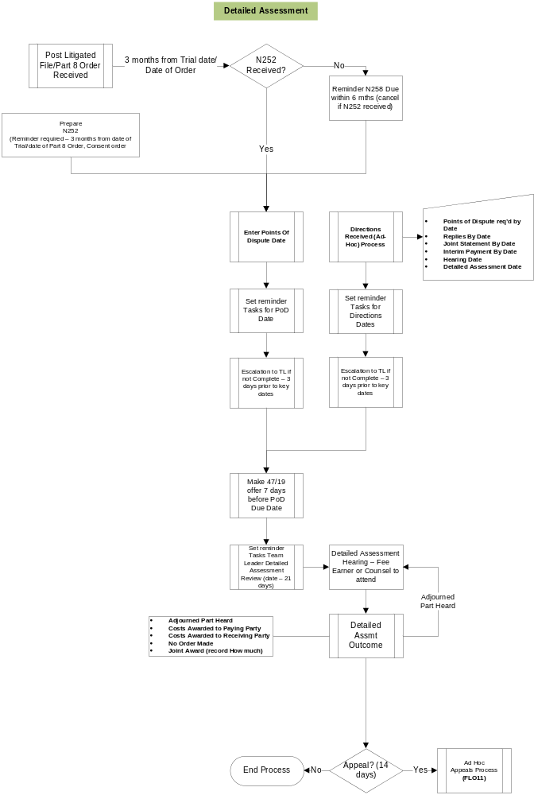
Fig – Costs Assessment Process

Navigation

  - Where will the Flow be launched from

The flow for Costs Detailed Assessment will be launched from the Case Details screen, except where the process of Detailed Assessment is initiated by the selection of one of the time limited reminder tasks created when the case is assigned to costs: Part 8 Application for a Costs order or where BLM makes an application for a hearing (N258) :

- Upon the user completing the Assign Case to Costs task from the Case Actions Screen, the system will schedule a task to be completed in the Case Pending Tasks “Process Part 8 Claim”. Upon selection of that task the Process Part 8 Form will be launched
- The Flow can also be launched by a user selecting “Part 8 Claim” from the Ad-Hoc Tasks list.

  - Where should the Flow return to

- See Each Form for flow returns

SQL Tables

  - Tables

    - New Data Table in Database: dbo.DetailedAssessment

Add field list with types (I know this is in the fields section but it avoids confusion)

DetailedAssessment_DetailedAssessmentID [int] IDENTITY(1,1) NOT NULL,
DetailedAssessment_CaseID [int] NOT NULL,
DetailedAssessment_Code [int] NOT NULL,
DetailedAssessment_CostCourtID [int] NULL,
DetailedAssessment_DAHAttend [int] NULL,
DetailedAssessment_DAHResult [nvarchar] (50) NULL
DetailedAssessment_DAHAppeal [Bit] NULL
DetailedAssessment_DAHAppealBy [nvarchar] (50) NULL
DetailedAssessment_InActive [Bit] NULL
DetailedAssessment_CreateDate [smalldatetime] NOT NULL,
DetailedAssessment_CreateUser [nvarchar] (255) NOT NULL,

  - New fields

New costs marker field in the Case table (please add more detail)

Case_CostsAssign [Bit] NULL

  - Lookup

New Values in dbo.KeyDatesType of:

dbo.KeyDatesType_Description | dbo.KeyDatesType _Code
Date Assigned to Costs | CostsAssignDate
Date of Authority To Assess | CostsAuthAssess
Final Date For Notice of Commencement | CostsN252By
Final Date for Request For Hearing | CostsN258By
Date of Part 8 Order | Prt8OrderDte
N252 Date of Service | N252DteSvd
N258 Date of Service | N258DteSvd
Summary Assessment Date | SummAssDte
Points of Dispute Due Date | PoDDueDate
47.19 Offer Due By | 4719Offer
Replies to POD By | RepliesDueBy
Points Of Dispute Completed | PoDCompDate
Joint statement meeting By | JSMtgBy
Joint Statement Filed By | JSFileBy
Interim Payment By | IntPytBy
Detailed Assessment Hearing Date | DAHDate
Appeal By Date | DAHAppealDate
Costs Settled Date | CostsSttldDate

New Values in dbo.LookupCode of:

dbo.LookupCode_Description | dbo.LookupCode_LookupTypeCode
Adjourned Part Heard | DAHResult
Adjourned | DAHResult
Costs Awarded to Paying Party | DAHResult
Costs Awarded to Receiving Party | DAHResult
Joint Costs Award | DAHResult
No Costs Order Made | DAHResult
Vacated by Consent | DAHResult
Lawyer | DAHAttend
Counsel | DAHAttend
Costs Draftsperson | DAHAttend
External Costs Draftsperson | DAHAttend
BLM | DAHAppeal
Third Party | DAHAppeal

  - Fields & Forms

Label | Input Type | Table | Field Name | Field Value Type | Mandatory? | Rule | Form | Description

Stored Procedures

  - Fetch

New Stored Procedure:

- LTMM_CostsDirections_Fetch
- LTMM_DetailedAssessment_Fetch

  - Save

New Stored Procedure:

- LTMM_CostsDirections_Save
- LTMM_DetailedAssessment_Save

Tasks & Reminders

Task | Who On | Trigger | Behaviour on Select | Scheduling | Conditions/Parameters
Make 47.19 Offer by <Date> | Costs Draftsperson | value entered in dbo.CaseKeyDates where @pKeyDatesCode = ‘4719Offer’ | Load Offers Tab for Costs Draftsperson | value entered in dbo.CaseKeyDates where @pKeyDatesCode = ‘4719Offer’ | None
Prepare Points of Dispute by <Date> | Costs Draftsperson | value entered in dbo.CaseKeyDates where @pKeyDatesCode = ‘PoDDueDate’ | Produce Points of Dispute form for Costs Draftsperson in the Matter to edit | value entered in dbo.CaseKeyDates where @pKeyDatesCode = ‘PoDDueDate’ | Escalate to Costs Supervisor in the Matter for 3 Days prior to <Date> if uncompleted
Replies to Points of Dispute Due <Date> | Costs Draftsperson | value entered in dbo.CaseKeyDates where @pKeyDatesCode = ‘RepliesDueBy | Write history line to dbo.AppTask as follows: “Replies to Points of Dispute received on <Today’s Date>” | value entered in dbo.CaseKeyDates where @pKeyDatesCode = ‘RepliesDueBy
Joint Statement Meeting to be Held by <date> | Costs Draftsperson | value entered in dbo.CaseKeyDates where @pKeyDatesCode = ‘JSMtgBy’ | Write history line to dbo.AppTask as follows: “Joint Statement Meeting Held on <Today’s Date>” | value entered in dbo.CaseKeyDates where @pKeyDatesCode = ‘JSMtgBy’
Joint Statement to be Filed By <Date> | Costs Draftsperson | value entered in dbo.CaseKeyDates where @pKeyDatesCode = ‘JSFileBy’ | Write history line to dbo.AppTask as follows: “Joint Statement Prepared by <user> on <Today’s Date>” | value entered in dbo.CaseKeyDates where @pKeyDatesCode = ‘JSFileBy’ | Escalate to Costs Supervisor in the Matter for 3 Days prior to <Date> if uncompleted
Interim Payment By <Date> | Costs Draftsperson | value entered in dbo.CaseKeyDates where @pKeyDatesCode = ‘IntPytBy’ | Write history line to dbo.AppTask as follows: “Interim Payment Prepared by <user> on <Today’s Date>” | value entered in dbo.CaseKeyDates where @pKeyDatesCode = ‘IntPytBy’
Prepare Detailed Assessment Hearing by <Date> | Costs Draftsperson | value entered in dbo.CaseKeyDates where @pKeyDatesCode = ‘DAHAppealDate’ | Load Detailed Assessment Hearing Form for Costs Draftsperson to complete | value entered in dbo.CaseKeyDates where @pKeyDatesCode = ‘DAHAppealDate’ | Escalate to Costs Supervisor in the Matter for 3 Days prior to <Date> if uncompleted
Review Detailed Assessment Hearing Preparations | Costs Supervisor | value entered in CaseKeyDates where @pKeyDatesCode = ‘DAHDate’ | Write history line to dbo.AppTask as follows: “Detailed Assessment Preparations reviewed by <user> on <Today’s Date>” | value entered in CaseKeyDates where @pKeyDatesCode = ‘DAHDate’ MINUS 21 Days
Appeal Due By <Date> | Costs Draftsperson | value entered in dbo.CaseKeyDates where @pKeyDatesCode = ‘DAHAppealDate’ | Set Task Appeal Due By <Date> as complete | value entered in dbo.CaseKeyDates where @pKeyDatesCode = ‘DAHAppealDate’ | Escalate to Costs Supervisor in the Matter for 3 Days prior to <Date> if uncompleted

Document Templates

Please list below details of any document required as part of this scope.

Status:  New / Existing / Replacement  (please state) | Received Document Name (from business) | Document File Name  (ie Document.dot) | Document Description  (as viewed on FloCase) | Template Description Code  (Code for auto description) | Template Group:  BLM/ Documents/ Court Doc/ Letters/ Other  (Please State)
New | Points of Dispute Form | TBA | TBA | TBA | Documents
New | Joint Statement Form | TBA | TBA | TBA | Documents
New | Bill of Costs | TBA | TBA | TBA | Documents
New | Precedent H (Defence Schedule of Costs) | TBA | TBA | TBA | Documents

/tmp/lo/0000.doc

